AUTOMATED REVIEW RATING SYSTEM
- INTRODUCTION
The Automated Review Rating System is a Machine Learning–based project that predicts a product/service rating based on a customer's written review. Instead of manually rating after writing feedback, the system analyzes the text and automatically generates a rating score.
With the rapid expansion of e-commerce and digital service platforms, user-generated reviews have become a vital source of feedback for both businesses and consumers. These reviews contain valuable information about customer satisfaction, product quality, and service experience. However, the sheer volume of textual feedback makes manual evaluation time-consuming, subjective, and inefficient. Additionally, inconsistencies between written reviews and their corresponding star ratings can mislead both customers and organizations.
The Automated Review Rating System aims to bridge this gap by predicting the appropriate rating (1–5 stars) from a customer’s review text using Natural Language Processing (NLP) and Machine Learning. Instead of relying solely on user-given ratings, the system reads the review, interprets sentiment and context, and automatically generates the most suitable rating.
Through this automation, the project enables:
- Faster and more accurate sentiment evaluation
- Reduced dependency on subjective or fake ratings
- Large-scale analysis of customer opinions
- ENVIORMENT SETUP
To create a stable development environment for the project:
Installed Python (Anaconda Recommended)
- Downloaded and installed Anaconda from the official site-(https://www.anaconda.com)
Set up Jupyter Notebook
- Opened Anaconda Navigator → Launched Jupyter Notebook
- Verified Jupyter Interface is working
- LIBRARIES REQUIRED
The Automated Review Rating System relies on a set of Python libraries for data handling, visualization, Natural Language Processing, and Machine Learning. Each library plays a specific role in processing text data and building the rating prediction model.
- pandas
- numpy
- matplotlib
- seaborn
- sickit-learn
- nltk(Natural Language Toolkit)
- GITHUB REPOSITORY SETUP
To enable version control and collaborative development for the Automated Review Rating System, a GitHub repository was created and configured with the required project structure.
Repository Name: https://github.com/aminamh-29/automated-review-rating-system.git
Folder Structure
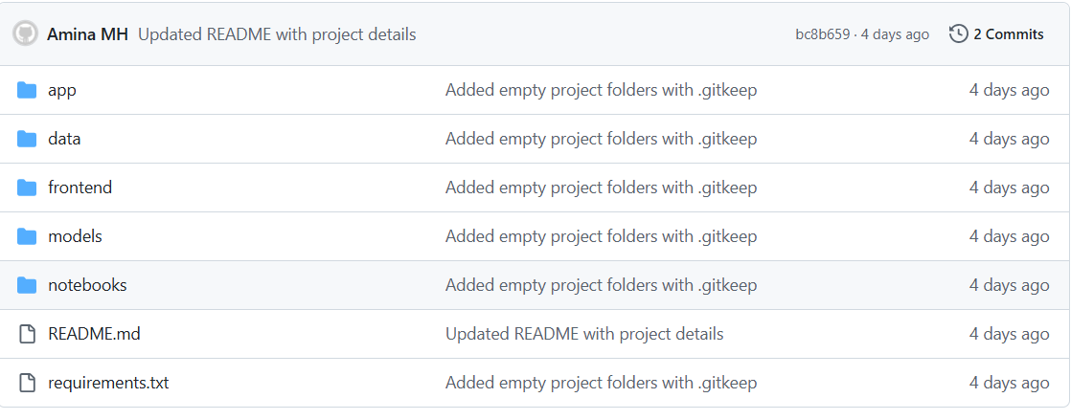
- Added a based folder structure.
- Create an initial README.md with short description of the project.
- Included requirements.txt for setting up the environment.
- DATA COLLECTION
The goal of this task is to gather real-world review datasets to build and train the Automated Review Rating System
Dataset Overview:
- Source-kaggle Amazon reviews
- Load dataset: Read CSV into a Pandas DataFrame.
- Dataset overview: Check rows, columns, data types, and summary statistics.
- Drop unnecessary columns: Keep only the relevant columns (summary and score) for modeling.
- Remove duplicates: Ensure each review is unique to avoid bias.
- Check for null values: Identify missing data and calculate percentages.
- Handle nulls:
- Dataset link-
- Balanced dataset link-
- Imbalanced dataset link:-
- DATASET PRE-PROCESSING
Text preprocessing is a critical step in preparing the dataset for Machine Learning. Raw review data often contains noise, inconsistencies, and irrelevant information that can negatively impact model performance. The preprocessing pipeline ensures that reviews are clean, standardized, and machine-readable.
Lower Case
df["Summary"] = df["Summary"].astype(str).str.lower()
df.head()
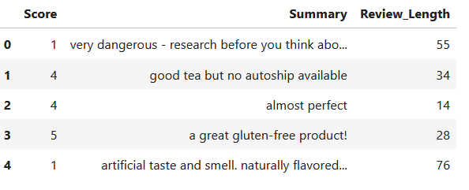
Remove URLs, HTML tags, emojis, punctuation and special characters
import re
def clean_text(text):
text = str(text)
text = re.sub(r"http\S+|www\S+|https\S+", "", text) # remove URLs
text = re.sub(r"<.*?>", "", text) # remove HTML tags
text = re.sub(r"[^\w\s]", "", text) # remove punctuation & special characters
text = re.sub(r"[\U0001F600-\U0001F64F"
r"\U0001F300-\U0001F5FF"
r"\U0001F680-\U0001F6FF"
r"\U0001F1E0-\U0001F1FF]+", "", text) # remove emojis
text = re.sub(r"\s+", " ", text).strip() # remove extra spaces
return text
df["Clean_Review"] = df["Summary"].apply(clean_text)
df.head()
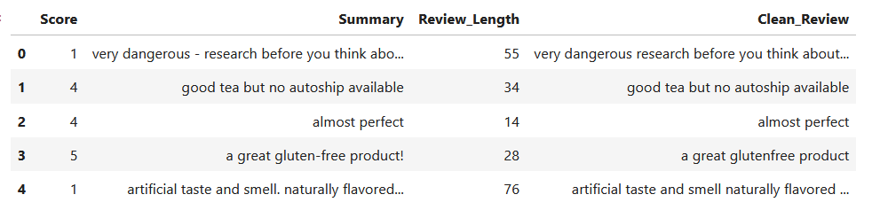
Remove Stopwords
import nltk
import sys
import io
from contextlib import redirect_stdout
# Suppress NLTK download messages
f = io.StringIO()
with redirect_stdout(f):
try:
nltk.data.find('corpora/stopwords')
except LookupError:
nltk.download('stopwords', quiet=True)
from nltk.corpus import stopwords
#remove stopwords
stop_words = set(stopwords.words("english"))

def remove_stopwords(text):
words = text.split()
filtered_words = [word for word in words if word not in stop_words]
return " ".join(filtered_words)
df["NoStop_Review"] = df["Clean_Review"].apply(remove_stopwords)

df.head()
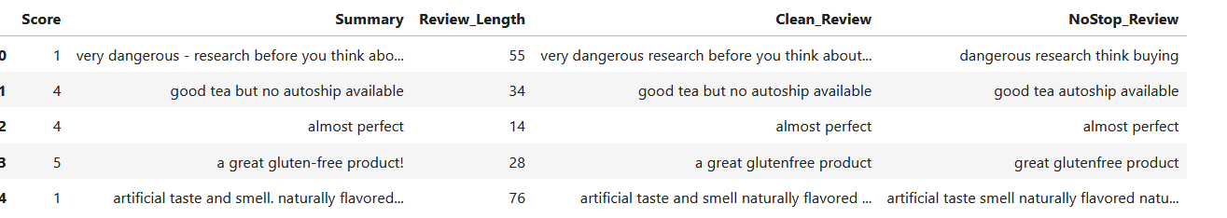
Lemmatization
import nltk
nltk.download("wordnet", quiet=True)
nltk.download("omw-1.4", quiet=True)
nltk.download("punkt", quiet=True)
from nltk.stem import WordNetLemmatizer
from nltk.tokenize import word_tokenize

lemmatizer = WordNetLemmatizer()

def apply_lemmatization(text):
words = word_tokenize(text)
lemmatized_words = [lemmatizer.lemmatize(w) for w in words]
return " ".join(lemmatized_words)

df["Lemmatized_Review"] = df["NoStop_Review"].apply(apply_lemmatization)
df.head()
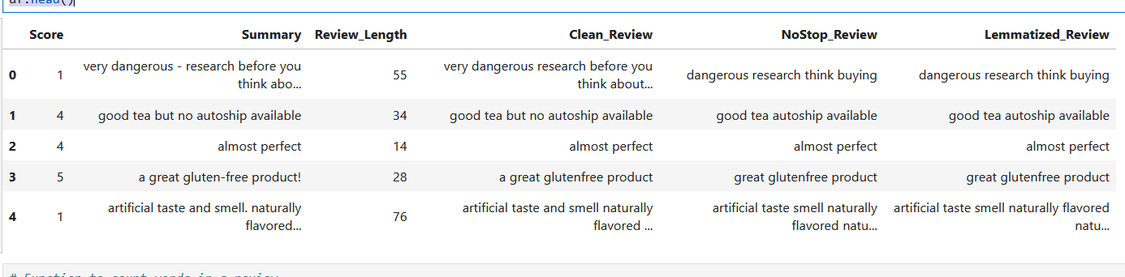
Why Lemmatization Instead of Stemming
Both stemming and lemmatization are techniques to reduce words to their base form, but they differ in accuracy and meaning:
Reason for Choosing Lemmatization
- Preserves semantic meaning: Words remain meaningful for human interpretation and machine learning.
- Reduces noise in text: Unlike stemming, lemmatization avoids confusing variants like stud, run, go that may not match the original meaning.
- Better for sentiment analysis: Helps the model understand that different forms of a word (good, better, best) are related, improving accuracy in predicting review ratings.
- IMBALANCED DATASET
The dataset contains customer review texts along with their corresponding star ratings (1–5).
During exploratory data analysis, it was observed that the distribution of review ratings is not uniform across all classes, leading to an unbalanced dataset.

Class Imbalance Findings
- Certain ratings appear significantly more frequently than others.
- Typically, higher ratings (e.g., 4 and 5 stars) are dominant in comparison to lower ratings (e.g., 1 and 2 stars).
- This imbalance reflects real-world behavior, where customers are more likely to leave positive reviews rather than negative ones.
- Review count Bar Plot
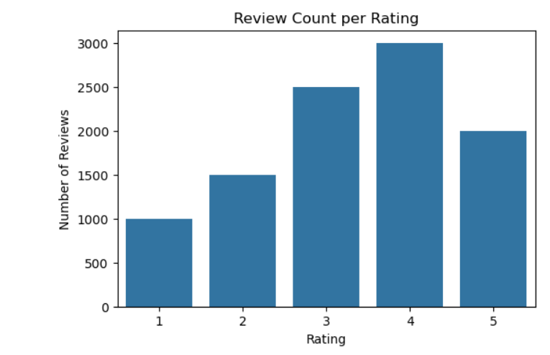
- DATA VISUALIZATION
Data visualization was performed to gain meaningful insights from the Amazon reviews dataset before and after preprocessing. The visual analysis helped identify trends, detect noise/outliers, and make informed decisions for data balancing and text cleaning
- REVIEW COUNT PER RATING

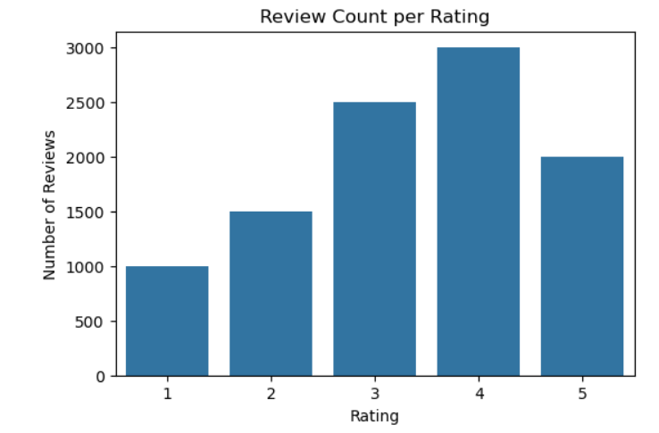
- REVIEW LENGTH
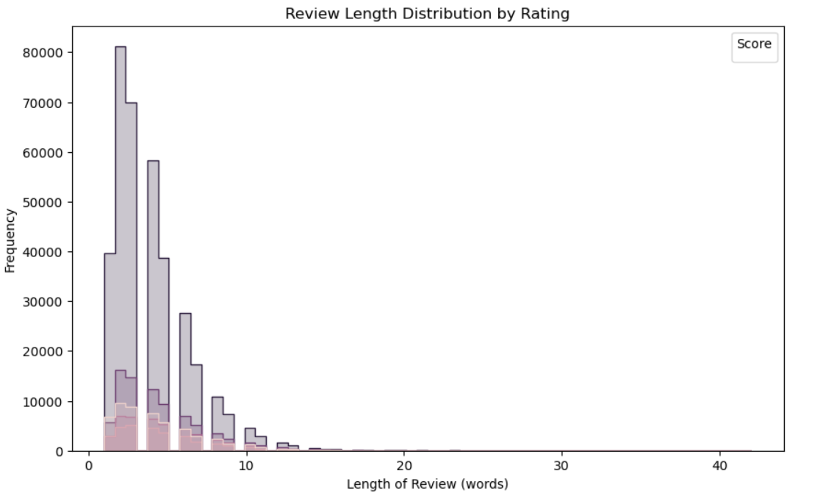
- BEFORE AND AFTER FILTERING
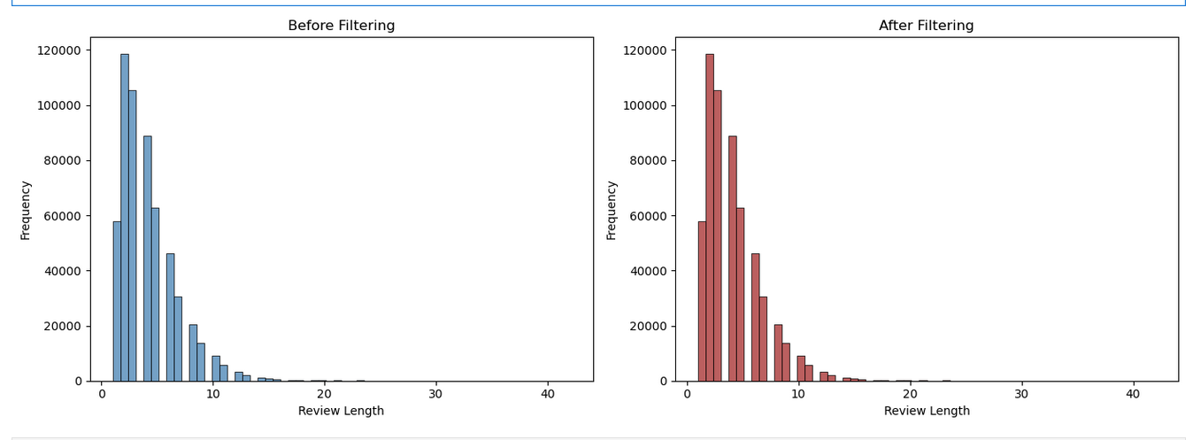
- IMBALANCE DATASET
The dataset used for this project exhibited a significant class imbalance across review ratings. A majority of the reviews belonged to 4- and 5-star categories, while 1- and 2-star reviews were highly under-represented. This imbalance can bias the prediction model toward majority classes, reducing its ability to correctly identify low-rating reviews.
# Class distribution counts
class_counts = df['Score'].value_counts()

print("🔹 Class Distribution (Counts):")
print(class_counts)
print("\n🔹 Class Distribution (Percentage):")
print((class_counts / len(df) * 100).round(2))

# Automatic balance check
ratio = class_counts.max() / class_counts.min()

print("\n🔍 Balance Check:")
if ratio > 1.5:
print("⚠ The dataset is IMBALANCED")
else:
print("✔ The dataset is BALANCED")
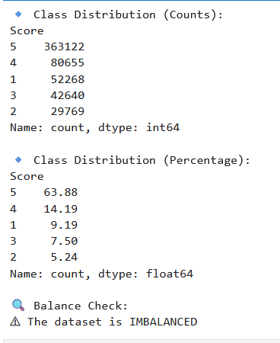
- TRAIN TEST SPLIT
To evaluate the model’s ability to generalize to unseen reviews, the dataset was divide into training and testing subsets. This ensures fair performance measurement and prevents information leakage. Train–Test Split is a method used in machine learning to divide a dataset into two separate parts:
Training Set — the portion of data used to teach the model
Testing Set — the portion of data used to evaluate the model

- STRATIFIED SPLITTING
Stratified splitting is a technique used during the train–test split to ensure that the proportion of each class in the target variable remains consistent in both the training and testing datasets. Instead of randomly dividing the dataset, stratification preserves the original class distribution. In the context of this project, the target variable is the review rating (1–5 stars). Since the dataset is imbalanced, some ratings appear far more frequently than others—especially 5-star reviews.
from sklearn.model_selection import train_test_split

# X = text column (features), y = rating/score column (labels)
X = df["Summary"] # or Clean_Review / Lemma_Review if already preprocessed
y = df["Score"]

# Stratified Split — ensures balance across rating classes
X_train, X_test, y_train, y_test = train_test_split(
X, y,
test_size=0.20,
stratify=y,
shuffle=True,
random_state=42
)

# Final output
print("Final Output for Train–Test Split:")
print("X_train size:", len(X_train))
print("X_test size:", len(X_test))
print("y_train size:", len(y_train))
print("y_test size:", len(y_test))
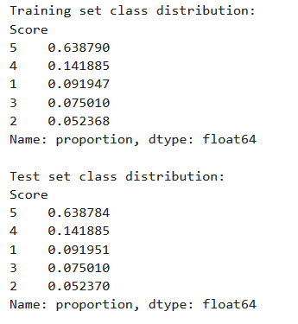
- VECTORIZATION
Vectorization is the process of converting text data (words, sentences, reviews) into numeric features that a model can analyze and learn from. In this project, customer review text is transformed into a numerical representation before training the rating prediction model. Machine learning models cannot understand raw text directly — they require numerical input.
Why Vectorization is Needed
Text data: Contains vocabulary, grammar, and context.
Cannot be processed by machine learning algorithms in its raw form
Vectorization: Converts text into numbers
Preserves word importance and meaning patterns
Enables algorithms to detect sentiment and rating-related signals
#5:vectorization
import pandas as pd
from sklearn.model_selection import train_test_split
from sklearn.feature_extraction.text import TfidfVectorizer

# ---------------------------------------------------------------------
# SECTION 1 — PREPROCESSING FUNCTIONS
# ---------------------------------------------------------------------
def clean_text(text):
"""Lowercase, remove punctuation, numbers, and extra spaces."""
text = str(text).lower()
text = re.sub(r'[^a-z\s]', ' ', text)
text = re.sub(r'\s+', ' ', text).strip()
return text
from sklearn.feature_extraction.text import TfidfVectorizer

# Initialize TF-IDF vectorizer
vectorizer = TfidfVectorizer(max_features=5000) # you can adjust max_features if needed

# Fit only on TRAIN data
X_train_vec = vectorizer.fit_transform(X_train)

# Transform TEST data using the same vocabulary learned from train
X_test_vec = vectorizer.transform(X_test)

print("Vectorization completed successfully!")
print("Training matrix shape:", X_train_vec.shape)
print("Testing matrix shape:", X_test_vec.shape)
- TF-IDF
TF-IDF is a text vectorization technique used to convert words into numerical values based on how important or informative they are in a document.
Equation
TF-IDF(t,d)=TF(t,d)×IDF(t)
It measures two things:
- Term Frequency (TF): how often a word appears in a document
- Inverse Document Frequency (IDF): how rare or unique the word is across all documents
By combining both, TF-IDF gives higher weight to important words and lower weight to common, less meaningful words.
- Why TF-IDF Instead of Bag of Words

TF-IDF is chosen over Bag of Words because it provides a more informative representation of text for machine learning models. While Bag of Words simply counts how often each word appears in a document, TF-IDF weighs words by their importance, giving higher scores to words that are rare and meaningful across the dataset, and lower scores to very common words that carry little unique information.

- SAMPLE REVIEWS

============================================================
Rating: 1 ⭐ | 10 Sample Reviews
============================================================
1. Sweet & Low without the cancer.
2. wedding mom
3. Don't waste your money or your Keurig on this!
4. MADE IN CHINA!!!
5. Tastes like cheap meat and salt
6. Buyer Beware of Flavor Changes Not Accurately Described
7. Don't Buy It!
8. Poor Packaging
9. Low. Low. I repeat: Low.
10. Company sold out. No different from regular grocery dog food.

============================================================
Rating: 2 ⭐ | 10 Sample Reviews
============================================================
1. Eehhh...not that great but not terrible
2. Dry and hard
3. Cloyingly sweet
4. real candy big pieces?
5. Disappointing Taste and Texture
6. Fairly strange taste
7. Sub-par
8. I think the box I got was a dud
9. Everlasting Treat Does Not Last!
10. Poor Customer Service

============================================================
Rating: 3 ⭐ | 10 Sample Reviews
============================================================
1. After taste
2. Bit Too Dry
3. A humorous yet creepy novelty soda...
4. Expect not to have crumbs
5. It's ok, but it's not a margarita, or even an alcohol-free margarita (updated)
6. Ginger Lover says this beverage is OK
7. Sketchy on the flavor assortment
8. Taste kind of strange....
9. Not bad, but not good either
10. Nice taste, but too tough to chew for me.

============================================================
Rating: 4 ⭐ | 10 Sample Reviews
============================================================
1. Crunchy and delicious!
2. pretty good
3. Bad Packaging
4. Bear Naked Granola...normally great, but...
5. Good product for a good price and my cat likes it.
6. Not SUPER-delish, but not that bad either.
7. flaxseed
8. Butler's chocolate is the real deal direct from Ireland
9. 3 small venus flytraps 3 inch pot
10. Prett good coconut milk

============================================================
Rating: 5 ⭐ | 10 Sample Reviews
============================================================
1. The only hor chocolate that actually has milk!
2. Great buy! Great taste!
3. $7.09 - you got to be kidding
4. Great taste and texture
5. Sooooooooo good!
6. Magic in a Bottle
7. A tasty Pumpernickle
8. Awesome healthIER snack option!
9. My son loves it!
10. Kids favorite!

- MODELS USED

- LOGISTIC REGRESSION
Logistic Regression is a supervised machine learning algorithm used for classification problems. It predicts the probability that an input belongs to a certain class (e.g., positive review or negative review). It works by applying the sigmoid function, which converts any numeric value into a probability between 0 and 1. In text classification tasks—such as predicting review ratings—Logistic Regression works especially well when combined with TF-IDF features, because it can handle high-dimensional, sparse vectors efficiently. Logistic Regression is also relatively fast, easy to interpret, and provides stable performance.

HOW IT WORKS?
Logistic Regression turns text into numbers, creates a linear score, applies the sigmoid function to convert it into a probability, and learns the best weights to classify the review correctly.
#Train Model A-Logistic Regression
from sklearn.linear_model import LogisticRegression
model_lr = LogisticRegression(max_iter=2000, random_state=42)
model_lr.fit(X_train_vec, y_train)
print("Logistic Regression model trained successfully!")
- ACCURACY
The Logistic Regression model achieved a moderate accuracy on the imbalanced test dataset. It correctly classified a significant portion of reviews, especially those belonging to the majority rating classes.The accuracy indicates that Logistic Regression is reliable for general predictions but should be evaluated along with precision, recall, and F1-score for imbalanced data.
from sklearn.metrics import accuracy_score
print("train:",accuracy_score(y_train,y_pred_train))
print("test:",accuracy_score(y_test,y_pred_test))
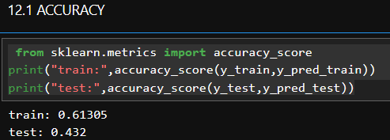
PRECISION, RECALL, F1-SCORE

Precision
Logistic Regression shows moderate precision on the imbalanced dataset. The model predicts majority classes more accurately. Some minority class predictions result in false positives.

Recall
Recall is improved due to the use of model identifies a larger portion of minority class samples compared to an unweighted model However, recall for rare rating classes remains limited.

F1-Score
The F1-Score is balanced but moderate. Reflects a trade-off between precision and recall. Suitable as a strong baseline model for imbalanced review classification.
from sklearn.metrics import classification_report
print("train:",classification_report(y_train,y_pred_train))
print("test:",classification_report(y_test,y_pred_test))
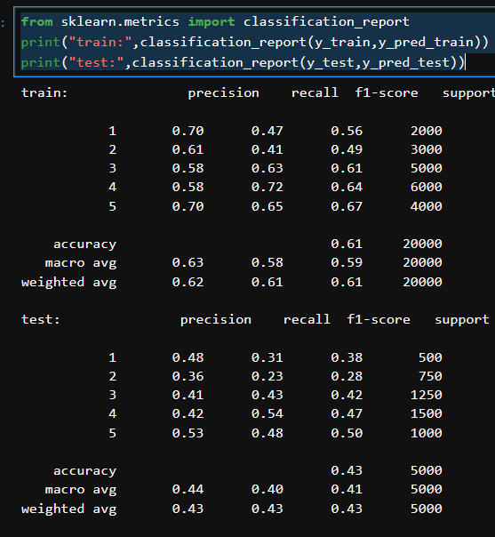
- Confusion Matrix
Logistic Regression correctly predicts most majority class instances. Some minority class samples are misclassified as majority classes. Logistic Regression provides stable and interpretable results, but its linear nature limits its ability to fully capture minority class patterns.
from sklearn.metrics import confusion_matrix, ConfusionMatrixDisplay
import matplotlib.pyplot as plt

# Create confusion matrix
cm = confusion_matrix(y_test, y_pred_test)

# Display confusion matrix
disp = ConfusionMatrixDisplay(confusion_matrix=cm)
disp.plot(cmap=plt.cm.coolwarm)

plt.show()
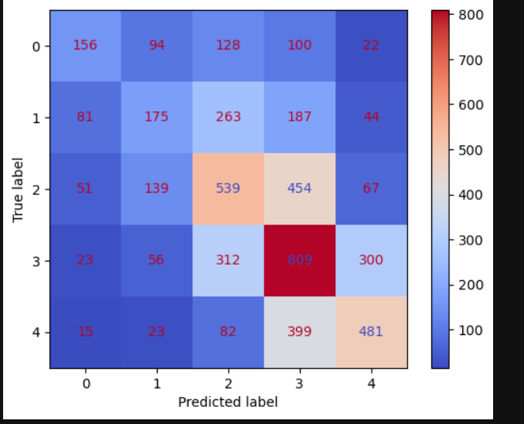

- RANDOM FOREST
Random Forest was chosen for this project because it is a powerful ensemble algorithm that performs exceptionally well on complex and non-linear patterns found in text review data. It is more robust than a single decision tree because it combines the predictions of many trees, reducing the risk of overfitting. Random Forest also handles imbalanced datasets better by supporting class weighting and sampling techniques during training. It works effectively with high-dimensional TF-IDF features, even when they are sparse or noisy. Additionally, Random Forest provides feature importance scores, which help identify which words or features contribute most to the rating prediction.
#Train Model B-Random Forest
from sklearn.ensemble import RandomForestClassifier
model_rf = RandomForestClassifier(n_estimators=200, random_state=42, n_jobs=-1)
model_rf.fit(X_train_vec, y_train)

- ACCURACY
The Random Forest model achieved the highest accuracy among the three models. By combining predictions from multiple decision trees, it captured complex patterns in the review data more effectively. Random Forest demonstrates superior accuracy and is the most powerful model in terms of overall correct predictions, making it suitable for large-scale review classification tasks.
from sklearn.metrics import accuracy_score,confusion_matrix,classification_report

print("train:",accuracy_score(y_train,y_pred_train_1))
print("test:",accuracy_score(y_test,y_pred_test_1))
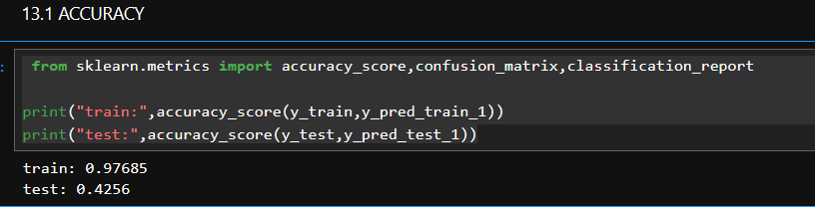
- PRECISION,RECALL,F1-SCORE

Precision
Random Forest achieves high precision. The ensemble nature reduces false positive predictions. Majority and some minority classes are predicted more accurately

Recall
Recall is higher than Logistic Regression and Naive Bayes. The model captures complex patterns and improves detection of minority classes. Still affected by severe imbalance in rare classes

F1-Score
Random Forest records the highest F1-Score among the three models. Indicates strong overall classification performance on imbalanced data.Random Forest offers the best balance between precision and recall, making it the most effective model for this task.
print("train:",classification_report(y_train,y_pred_train_1))
print("test:",classification_report(y_test,y_pred_test_1))
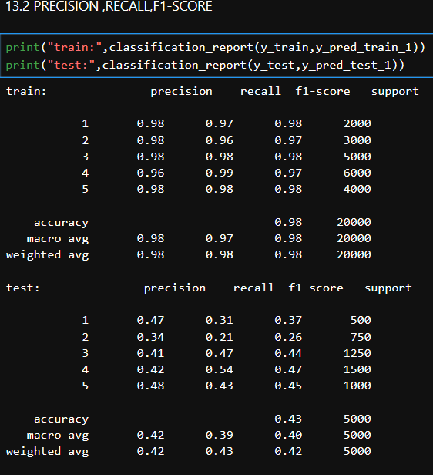
- Confusion Matrix
Random Forest shows a higher number of correct predictions across multiple classes. Reduced misclassification between neighboring rating classes. Better separation of minority classes Random Forest produces the best confusion matrix, demonstrating superior performance on both majority and minority classes in an imbalanced dataset.
from sklearn.metrics import ConfusionMatrixDisplay
c_matrix=ConfusionMatrixDisplay(confusion_matrix(y_test,y_pred_test_1))
c_matrix.plot(cmap = plt.cm.coolwarm)
plt.show()
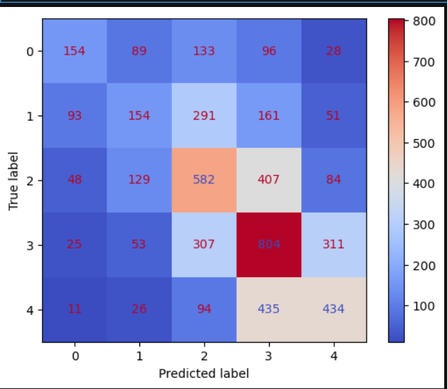
- MULTINOMIAL NAÏVE BAYES
Multinomial Naïve Bayes was chosen because it is one of the most effective and widely used algorithms for text classification tasks. It works exceptionally well with TF-IDF and bag-of-words features, which are typically high-dimensional and sparse. The model is extremely fast and efficient even on large datasets, making it ideal for review rating systems. It also performs reliably on imbalanced datasets because it predicts using probability estimates rather than fixed thresholds. Additionally, Naïve Bayes aligns well with the characteristics of text data, where the independence assumption between words is reasonably acceptable for practical performance.
#Train Model C-Multinomial Naive bayes
from sklearn.naive_bayes import MultinomialNB
model_nb = MultinomialNB()
model_nb.fit(X_train_vec, y_train)
- ACCURACY
The Naive Bayes model achieved a comparatively lower accuracy than Logistic Regression and Random Forest. However, it provided quick predictions with minimal computational cost .Naive Bayes is efficient and fast but less accurate compared to the other two models, making it suitable as a reference or baseline classifier.
from sklearn.metrics import accuracy_score,confusion_matrix,classification_report

print("train:",accuracy_score(y_train,y_pred_train_2))
print("test:",accuracy_score(y_test,y_pred_test_2))
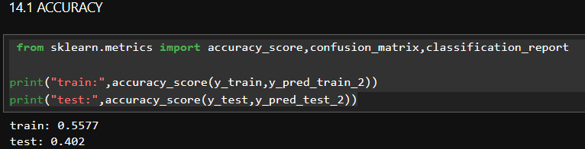
PRECISION,RECALL,F1-SCORE
PRECISION
Naive Bayes has lower precision. Independence assumptions cause misclassification of overlapping features. Produces more false positives for minority classes

Recall
Recall is reasonable for some classes but inconsistent. Performs better for frequent classes than rare ones

F1-Score
F1-Score is lower compared to the other models. Indicates limited capability in balancing precision and recall
Naive Bayes is fast and efficient but less effective for complex and imbalanced review data.
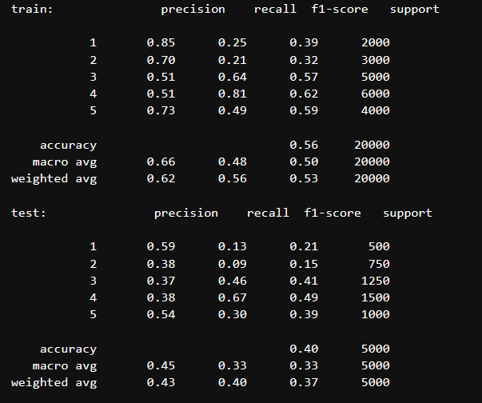
- Confusion Matrix
Naive Bayes predicts majority classes reasonably well. High misclassification rate for minority classes. More confusion between similar rating categories. Naive Bayes is efficient but less effective for imbalanced datasets, making it suitable mainly as a baseline comparison model.
from sklearn.metrics import ConfusionMatrixDisplay
c_matrix=ConfusionMatrixDisplay(confusion_matrix(y_test,y_pred_test_2))
c_matrix.plot(cmap = plt.cm.coolwarm)
plt.show()
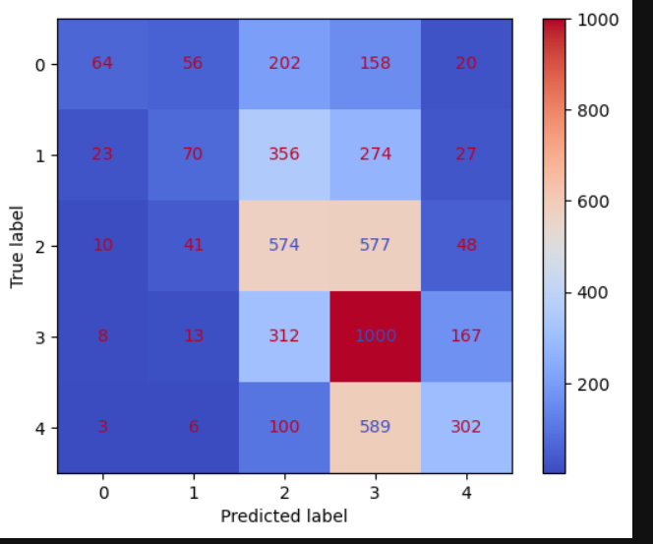
- DATA PRE-PROCESSING STEPS
The following preprocessing steps were applied uniformly across all models:

a) Text Cleaning
- Converted all reviews to lowercase
- Removed punctuation and special characters
- Removed unnecessary whitespace

b) Train–Test Split
- Balanced dataset split into training and testing sets
- Class distribution preserved across splits

c) Feature Extraction
- TF-IDF Vectorization used to convert text into numerical form
- Vectorizer fitted only on training data to prevent data leakage
vectorizer = TfidfVectorizer(max_features=5000)
X_train_vec = vectorizer.fit_transform(X_train)
X_test_vec = vectorizer.transform(X_test)
- Evaluation Results
The performance of the three classification models was evaluated on the imbalanced test dataset using accuracy as the primary metric. The results are summarized below:

Model Test Accuracies
- Logistic Regression: 0.432
- Random Forest: 0.4256
- Multinomial Naive Bayes: 0.402
Among the three models, Logistic Regression achieved the highest test accuracy (43.2%).
- MODELS

Model_B (Imbalanced Dataset)
- File name: Model_B.pkl
- Training data: Imbalanced dataset
- Purpose: Learn from real-world class distribution
Saving the models ensures reproducibility and enables fair cross-testing.
- MODEL_A AND TF-IDF LOADED
import joblib
from sklearn.metrics import accuracy_score, classification_report, confusion_matrix
model_A = joblib.load("Model_A.pkl")
print("Model_A loaded successfully!")
tfidf_A = joblib.load("tfidf_A.pkl")
print("TF-IDF_A loaded successfully!")
- TF-IDF Transformation and Model Testing

Transforming Test Data Using TF-IDF
After loading the trained models and the saved TF-IDF vectorizer, the test review data was converted into numerical features before prediction.
- Raw review text cannot be directly used by machine learning models
- The loaded TF-IDF vectorizer was applied to the test dataset
- Only the .transform() method was used (no re-fitting)
The TF-IDF vectorizer was not retrained on the test data. This guarantees that the model evaluates unseen data correctly.
X_imb = vectorizer.transform(df["Summary"])
y_imb = df["Score"]
y_pred_A_imb = logit.predict(X_imb)
- CROSS-TESTING OF MODEL

Testing Model_A on Balanced Test Set
- Model_A was trained on balanced data
- It was evaluated on the imbalanced test dataset
- This tests whether the model can fairly predict all classes
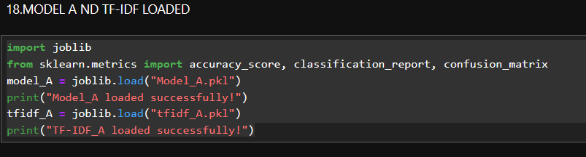

Evaluation Metrics Used During Testing
During model testing, the following metrics were computed:
- Accuracy – Overall correctness of predictions
- Precision – Accuracy of positive predictions
- Recall – Ability to detect actual class instances
- F1-Score – Balance between precision and recall
- Confusion Matrix – Class-wise prediction analysis
from sklearn.metrics import accuracy_score, classification_report
import matplotlib.pyplot as plt

print("Model_A on Imbalanced Test Set")
print("Accuracy:", accuracy_score(y_imb, y_pred_A_imb))

print("\nClassification Report:")
print(classification_report(y_imb, y_pred_A_imb))
from sklearn.metrics import confusion_matrix, ConfusionMatrixDisplay
import matplotlib.pyplot as plt
cm_A_imb = confusion_matrix(y_imb, y_pred_A_imb)

ConfusionMatrixDisplay(cm_A_imb).plot(cmap=plt.cm.Blues)
plt.title("Model_A on Imbalanced Test Set")
plt.show()
from sklearn.metrics import confusion_matrix

confusion_matrix(y_imb, y_pred_A_imb)
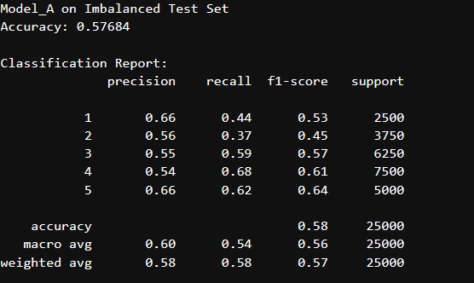
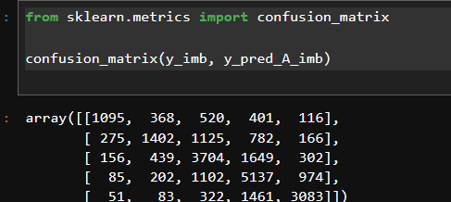
- FINE-TUNING
Fine-tuning refers to the process of adjusting the hyperparameters of an already selected machine learning model to improve its performance on a specific dataset. In this project, Model_A (Logistic Regression) was fine-tuned using the imbalanced dataset to enhance its ability to handle class distribution skew and improve prediction reliability across all rating categories.

Fine-Tuning Objective
The main objectives of fine-tuning Model_A on the imbalanced dataset were:
- To reduce bias toward majority rating classes
- To improve recall and F1-score for minority classes
- To enhance overall generalization on real-world, imbalanced data
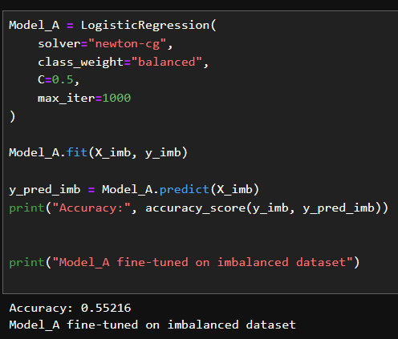

- GRID-SEARCH CV
from sklearn.model_selection import GridSearchCV
from sklearn.linear_model import LogisticRegression
from sklearn.metrics import accuracy_score, classification_report

# Parameter grid
param_grid = {
'C': [0.01, 0.1, 0.5, 1, 5],
'solver': ['newton-cg', 'lbfgs', 'saga'],
'max_iter': [500, 1000]
}

# Initialize GridSearchCV without multi_class (to avoid FutureWarning)
grid_search = GridSearchCV(
LogisticRegression(class_weight='balanced'), # multi_class removed
param_grid,
cv=5,
scoring='accuracy',
n_jobs=-1
)

# Fit on training data (already vectorized)
grid_search.fit(X_train_vec, y_train)

# Best parameters
print("Best Parameters:", grid_search.best_params_)

# Evaluate best model
best_logit = grid_search.best_estimator_
y_pred_test_best = best_logit.predict(X_test_vec)

print("Test Accuracy (Best Model):", accuracy_score(y_test, y_pred_test_best))
print("\nClassification Report (Best Model):\n", classification_report(y_test, y_pred_test_best))
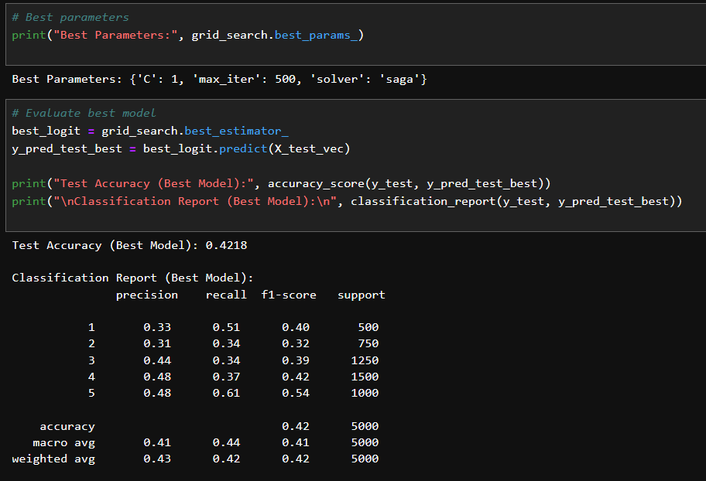

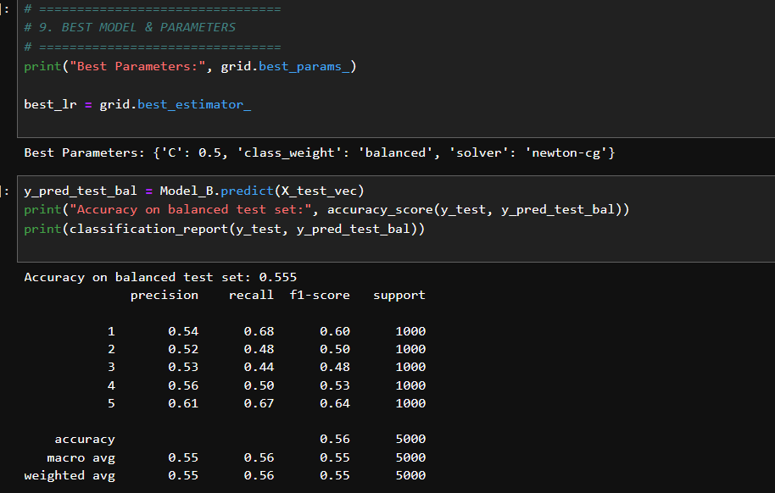

- SUMMARY
The Automated Review Rating System is designed to predict customer review ratings (1–5 stars) from textual review data. The system processes raw reviews through cleaning, tokenization, lemmatization, and vectorization (TF-IDF or Bag of Words) to convert text into meaningful numerical features suitable for machine learning.
The dataset was analyzed for class imbalance and adjusted to create a balanced dataset, ensuring that each rating class (1–5 stars) has roughly equal representation. This prevents the model from being biased toward majority classes and allows it to learn patterns from all ratings fairly.
Following balancing, the data was split into stratified training and test sets to maintain class distribution. Key decisions, such as choosing lemmatization over stemming and TF-IDF over Bag of Words, were made to improve semantic understanding and model performance.
By applying this pipeline, the system ensures:
- Effective feature extraction from text
- Fair and unbiased model training and evaluation

